Numerical Modeling of BRBs using SteelMPF
Gustavo A. Araújo R; Morgan K. McBain; Barbara G. Simpson
garaujor@stanford.edu;mmcbain@stanford.edu;bsimpson@stanford.edu
Stanford University
July 8, 2026

BRB Dataset
The calibration database comprises 16 BRB component-level specimens spanning wide ranges of core areas, yielding lengths, and cyclic loading protocols. A subset of these specimens, identified as the training set in Table 1, was used for parameter optimization. This subset includes eight pin-ended braces [1] and one weld-ended brace tested within a strongback-braced frame sub-assemblage [2]. The validation set corresponds to a more recent experimental campaign to characterize low-cycle fatigue in BRBs [3].
Table 1. BRB dataset used for model training and validation.
Name | Set | $f_{y}$  (MPa) | $A_{sc}$  (mm²) | $L_{y}$  (mm) | $L_{y}/L_{T}$  (-) | Reference
PC160 | Train | 290 | 2452 | 4470 | 0.79 | [1,4]
PC250 | Train | 290 | 3845 | 4557 | 0.81 | [1,4]
PC350 | Train | 290 | 5381 | 4656 | 0.83 | [1,4]
PC500 | Train | 272 | 8168 | 4701 | 0.83 | [1,4]
PC750A | Train | 290 | 11516 | 4679 | 0.83 | [1,4]
PC750B | Train | 290 | 11529 | 4557 | 0.81 | [1,4]
PC1200A | Train | 290 | 18406 | 4704 | 0.83 | [1,4]
PC1200B | Train | 290 | 18464 | 4605 | 0.82 | [1,4]
PC3SB | Train | 290 | 3225 | 1930 | 0.55 | [2,5]
A5 | Validation | 304 | 3652 | 3777 | 0.69 | [3]
B3 | Validation | 307 | 7226 | 3048 | 0.56 | [3]
B6 | Validation | 307 | 7226 | 3048 | 0.56 | [3]
B7 | Validation | 307 | 7226 | 3048 | 0.56 | [3]
B8 | Validation | 307 | 7226 | 3048 | 0.56 | [3]
C5 | Validation | 299 | 11135 | 2883 | 0.53 | [3]
CB225 | Validation | 290 | 1452 | 3111 | 0.70 | [6]

BRB Model
The hysteretic behavior of the BRBs was modeled using the Giuffrè–Menegotto–Pinto constitutive formulation [7,8] as extended by Filippou et al. [9] to incorporate isotropic strain hardening and by Kolozvari et al. [10] to allow asymmetric strength and hardening behavior in tension and compression. This formulation is implemented in OpenSees as SteelMPF, with the following syntax:
uniaxialMaterial SteelMPF $mattag $fyp $fyn $E0 $bp $bn $R0 $cR1 $cR2 $a1 $a2 $a3 $a4
The BRBs were modeled using a corotational truss element combined with stiff elastic end elements representing the connection regions [5]. As shown in Figure 1, the total BRB length, $L$, is decomposed into three physical regions: the connection regions of length $L_{j}$, the transition regions of length $L_{t}$, and the yielding steel core of length $L_{y}$. Inelastic deformations are assumed to occur only within the yielding core, characterized by area $A_{sc}$, whereas the transition regions, of area $A_{t}>A_{sc}$, are assumed to remain elastic.
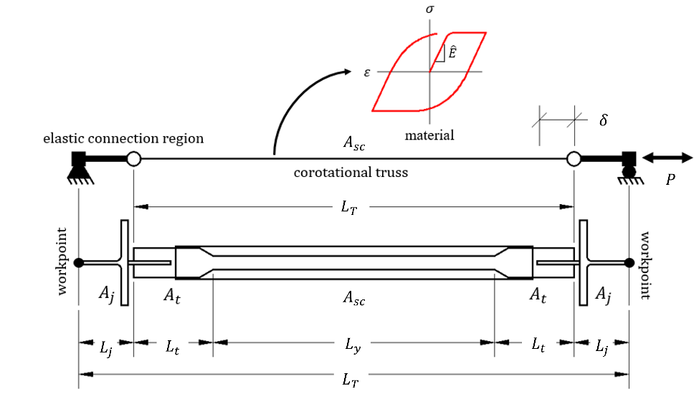
Figure 1. Schematic of BRB model.
To reproduce the global axial stiffness of the BRB without explicitly discretizing the transition regions, an effective stiffness factor, $Q$, was introduced to account for the series combination of the yielding and transition segments [11]:
$$Q=\frac{1}{\frac{{2L_{t}}/{L_{T}}}{{A_{t}}/{A_{sc}}}+\frac{L_{y}}{L_{T}}}.$$ | (2)
Using this formulation, the equivalent truss element of length $L_{T}$ and modified elastic modulus $\hat{E}=QE$ reproduces the combined axial stiffness of the yielding and transition regions. The connection regions are excluded from the computation of $Q$ because they are modeled explicitly.

Results
Table 2 shows the set of parameter values that were found to fit well the response of the train dataset and acceptably generalize the validation dataset. The experimental and numerically simulated force–deformation relationships are shown in Figure 2.
Table 2. Generalized SteelMPF parameters for the selected BRB dataset.
Parameter | Value | Description
$$f_{yp}$$ | $$f_{y}$$ | Tensile yield strength.
$$f_{yn}$$ | $$f_{y}$$ | Compressive yield strength.
$$\hat{E}$$ | $$QE$$ | Equivalent elastic modulus, with $E$ = 200 GPa and $Q$ from Eq. (2)
$$b_{p}$$ | 0.0049 | Tensile strain hardening ratio.
$$b_{n}$$ | 0.0233 | Compressive strain hardening ratio.
$$R_{0}$$ | 20.0 | Initial curvature parameter.
$$c_{R1}$$ | 0.88 | Curvature degradation parameter.
$$c_{R2}$$ | 0.19 | Curvature degradation parameter.
$$a_{1}$$ | 0.037 | Compressive isotropic hardening. It shifts the yield envelope by $Δσ=a_{1}f_{yn}$.
$$a_{2}$$ | 1.0 | Compressive isotropic hardening starts after a maximum tensile strain of $a_{2}f_{yp}/\hat{E}$.
$$a_{3}$$ | 0.035 | Tensile isotropic hardening. It shifts the yield envelope by $Δσ=a_{3}f_{yp}$.
$$a_{4}$$ | 1.0 | Tensile isotropic hardening starts after a maximum compressive strain of ${a_{4}f_{yn}}/{\hat{E}}$.

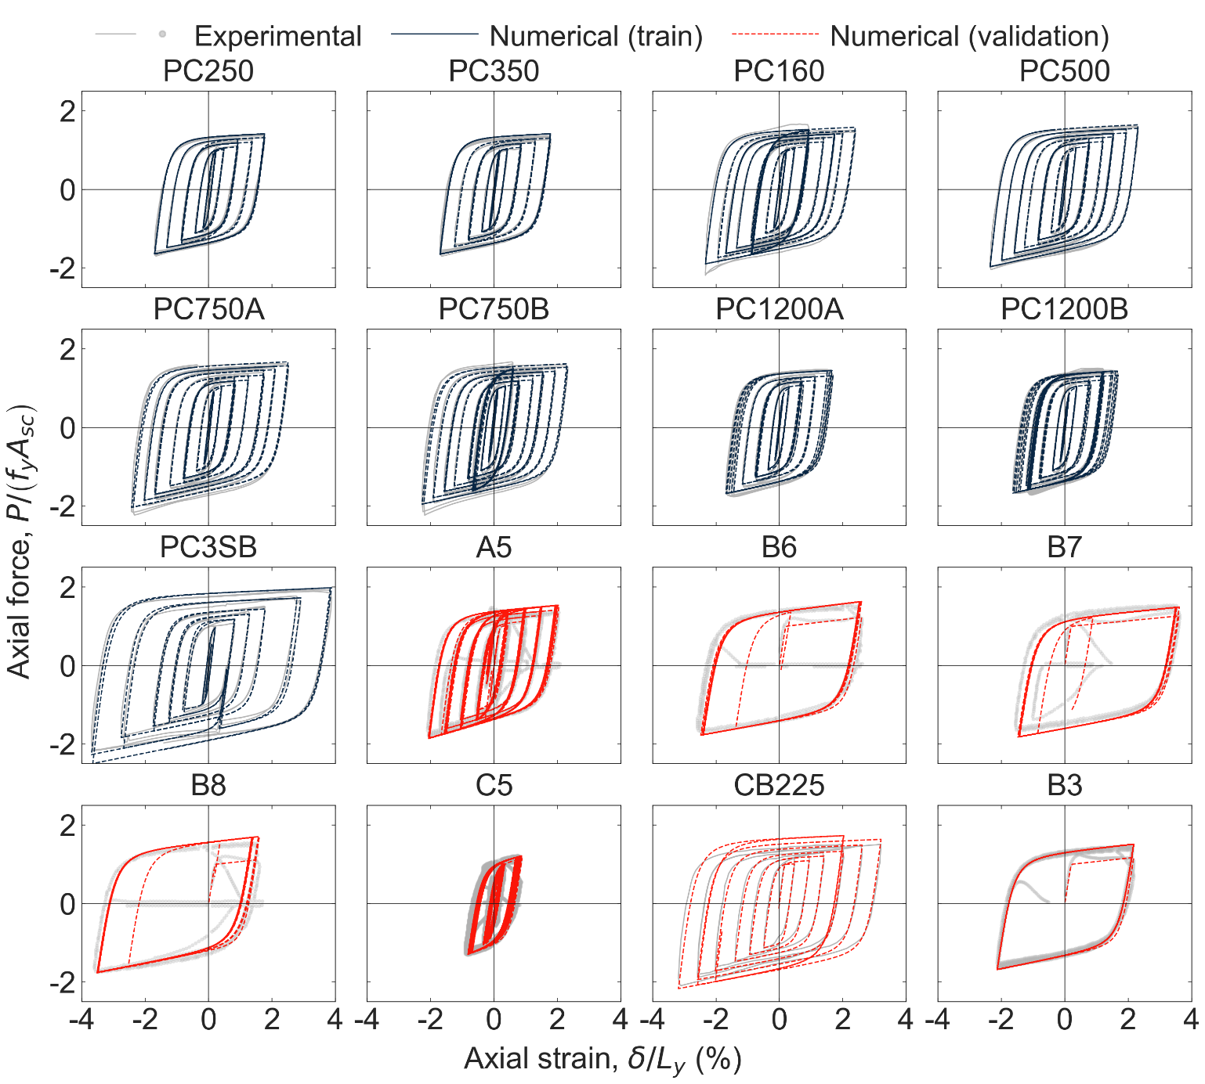
Figure 2. Generalized parameters for modeling BRBs with SteelMPF.

References
[1] Merritt S, Uang C-M, Benzoni G. Subassemblage Testing of Corebrace Buckling-Restrained Braces. La Jolla, California: University of California, San Diego; 2003.
[2] Simpson BG, Mahin SA. Experimental and Numerical Investigation of Strongback Braced Frame System to Mitigate Weak Story Behavior. Journal of Structural Engineering 2018;144:4017211. https://doi.org/doi:10.1061/(ASCE)ST.1943-541X.0001960.
[3] Li C-H, Vidmar Z, Saxey B, Reynolds M, Uang C-M. A Procedure for Assessing Low-Cycle Fatigue Life of Buckling-Restrained Braces. Journal of Structural Engineering 2022;148:4021259. https://doi.org/10.1061/(ASCE)ST.1943-541X.0003237.
[4] Zsarnóczay Á. Experimental and Numerical Investigation of Buckling Restrained Braced Frames for Eurocode Conform Design Procedure Development. Budapesti Műszaki és Gazdaságtudományi Egyetem, 2013.
[5] Simpson BG. Design Development for Steel Strongback Braced Frames to Mitigate Concentrations of Damage. University of California, Berkeley, 2018.
[6] Araújo R GA, Simpson B, Ho TX, Orozco O GF, Barbosa AR, Sinha A. Numerical Modelling of a Three-Story Building Using a Hybrid of Mass Timber Walls with Buckling-Restrained Braces. In: Mazzolani FM, Dubina D, Stratan A, editors. Proceedings of the 10th International Conference on Behaviour of Steel Structures in Seismic Areas. STESSA 2022. Lecture Notes in Civil Engineering., vol. 262, 2022. https://doi.org/10.1007/978-3-031-03811-2_45.
[7] GIUFFRE A. Il Comportamento Del Cemento Armato Per Sollecitazioni Cicliche di Forte Intensita. Giornale Del Genio Civile 1970.
[8] Menegotto M, Pinto PE. Method of analysis for cyclically loaded R.C. plane frames including changes in geometry and non-elastic behaviour of elements under combined normal force and bending. Rapports des commissions de travail AIPC = IVBH Berichte der Arbeitskommissionen = IABSE reports of the working commissions, vol. 13, IABSE; 1973, p. 15. https://doi.org/10.5169/seals-13741.
[9] Filippou FC, Popov EP, Bertero VV. Effects of Bond Deterioration on Hysteretic Behavior of Reinforced Concrete Joints. Berkeley, CA: Earthquake Engineering Research Center, University of California, Berkeley; 1983.
[10] Kolozvari K, Orakcal K, Wallace J. Shear-Flexure Interaction Modeling for Reinforced Concrete Structural Walls and Columns under Reversed Cyclic Loading. Berkeley, CA, United States: Pacific Earthquake Engineering Research Center; 2015.
[11] Tsai K-C, Wu A-C, Wei C-Y, Lin P-C, Chuang M-C, Yu Y-J. Welded end-slot connection and debonding layers for buckling-restrained braces. Earthquake Engineering & Structural Dynamics 2014;43:1785–807. https://doi.org/https://doi.org/10.1002/eqe.2423.

